RESUME

MENON MURALI MOHANDAS : MBA DEGREE HOLDER IN HR WITH MORE THAN 6 YEARS EXPERIENCE WITH WORLD RENOWNED ORGANIZATIONS

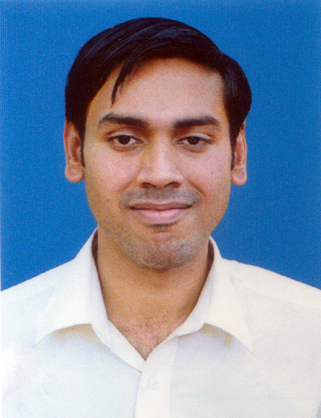

Murali Mohandas Menon,  Varshneyam, BharataPuzha Road, Kanniyampuram-679104,  Ottapalam. Dist. Palghat,  Kerala State | Tel (M) : 8281664854, 9962283260  E-mail : varshneyam@gmail.com  mmm205085@yahoo.co.in

Summary of Qualifications

Commerce/ Administrative/ Banking professional with more than SIX years experience in commerce, accounts, administration and marketing management. Attributes include excellent communication skills, efficient planning and marketing / administrative management. An extensive background in the following broad based skills / competencies:

- Excellent communication skills.
- Marketing
- Team Building / Development
- Strategic Planning
- Client Satisfaction
- Inspiring Leadership
- Key Relationships
- Ability to interface at all levels with key customer personnel and management.
- Accounting

ACHIEVEMENTS

- Received applause from the managers of companies for excellent working skills and punctuality in my work.
- Deputed to international conferences as the company’s representative for promoting the sales.
- The stores department of the company where I worked was set in order within a period of one month after joining the company.
- Adjudged as the best accounting personal in a reputed company.
- Received awrds from the banking organizations for the exemplary service demonstrated to the Bank Customers.

Professional Experience

Marketing / Customer Care Executive

Reliance India Limited (Web world), Bhavnagar

Key Functions:
- Marketing of Reliance communication products
- Follow up action on the performance of the instruments.
- Solving the trouble shootings .

Administrative/ Commercial Personnel
Rudraksh Detergents & Chemicals, Gandhidham (Kutch)
The Rudraksh Group is an India-based company working with International standards since 1953. Rudraksh Group’s businesses are Various Mineral processors for Fillers, Soaps & Detergent in collaboration with M/s. HUL, a multinational company, Warehousing with Stock Management & Logistics Services, Household goods & Consumer Durables outlet in Gujarat region.
Key Functions:
- Administrative assistance to the company’s managers in the smooth functioning of the organization.
- Liaison with outside agencies for the promotion of the company.
- Looking after all the commercial aspects of the company.
- Planning and guiding the departmental personnel to dispatch the goods as per demand in India as well as overseas.
- SAP entry
.

Commercial Personnel

Investment & Precision Casting Limited, Bhavnagar
(Manufacturer and exporter of ferrous and non ferrous investment castings)

Key Functions:
- Looking after all the commercial and marketing / logistic aspects of the company.
- Follow up with various auto mobile industries regarding the performance of the products and advising the company regarding improvements required, if any.
- To ensure timely dispatch of the items and the receipt of timely payment against the dispatch of goods
- Excise / customs related activities.

Stores Officer

M/s. Archean Chemical Pvt. Ltd., (Archean Group), Gandhidham

Key Functions:
- All the administrative, accounts and stores aspects of the company.
- Supervision of the plant installation at the identified site and ensure timely receipt and supply of goods to the company.

Customer care Officer

Eben Telecom, Kochi (Kerala)

Key Functions:
- Taking care of the valued customers of M/s FEDERAL BANK Ltd
- Attending to all the queries related to Banking raised by the customers and solving their issues on day to day basis.
- Bank account Upgradation and card protection

Assistant Manager (sales)

Indusind Bank Limited, Chennai

Key Functions:
- Looking after all the issues regarding banking of our customers..
- Card protection of the Bank customers
- Health Insurance schemes
- Account upgradation
- All other Bank related activities

WORKING KNOWLEDGE IN COMPUTERS
- Operating System
- DOS, Windows 98/2000/Vista
- Attended the training on networking program held at Bangalore during my college days.

Present Salary + Perks including incentives: 2.5 lac PA

Expected Salary: 3-3.5 lac PA

Education

Name of Examination | Subjects | Medium of Instruction | Year of passing | Class/Grade | Board/University
SSC | English, Maths, Science, Social Studies, Hindi, Sanskrit | English | March, 1999 | First Class (68.3%) | Secondary Board of Education, Gujarat
HSC | English, Hindi, Accounts, Eco, Commerce, Business Maths | English | April / May, 2001 | High Second Class (58.3%) | Higher Secondary Board of Education, Gujarat
B. Com. | English, Corporate Accounting (Auditing, Govt. A/C), Advance cost accounting, Management accounting, Financial management | English | March 2008 | Second Class (54.9%) | Bhavnagar University  (March 2008)
MBA | HR Management | English | December 2012 | B grade  (61.25%) | IIMRT, 1st ‘A’ Grade ISO 9001 – 2008 Management Research & Technical Institute, Ahmedabad, Bangalore, Bhubaneswar
Computer Course | General | English | --- | --- | GNIIT & PES Polytechnic, Bangalore
IRDA | Insurance | English | August 2014 | --- | ---

Personal Details

Date of Birth : 27-06-1983

Father’s name : Dr. V. P. Mohandas, Ex-Chief Scientist (CSIR)

Languages known :

English : Read, write and speak
Hindi : Read, write and speak
Gujarati : Read, write and speak
Malayalam : Speak

Extra Curricular activities : Cricket player, Junior Athletic champion
(During school days)

Hobbies : Reading, Listening to Music

(Menon Murali Mohandas)

